Community Care Support for You & Your Loved Ones

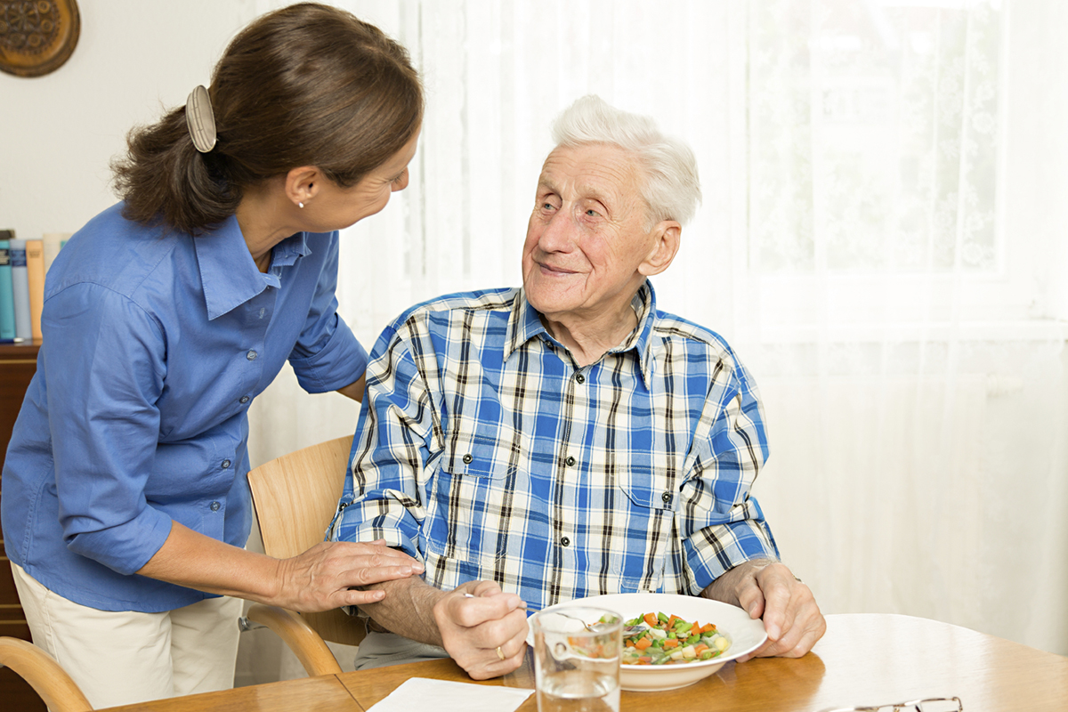

Care That Cares – One provide care that Our Own Family would be comfortable With

Here at Heart 2 Heart We understand the topic of care is not always an easy one to discuss. Deciding on the right care needs careful consideration to make sure it is suitable for you and your loved ones. Perhaps dad is struggling with the day to day running of the house or shows of Dementia or mum is feeling lonely after a bereavement and in need of Home help or companionship or a family member is struggling with just going out due to anxieties.

What is Home Care?
Unlike Residential Care, home care services allow your loved one to stay living in their own home whilst getting the help and support they need, whether they’re just looking for company or need someone to keep the house clean and prepare meals.
Home care is a great solution for someone who needs extra help in and around the house, as it allows them to remain independent and live happily within familiar surroundings. It’s also a great relief for family members who might not be able to provide support every time it’s needed or live far away and need peace of mind that their loved one is safe and well.
At Heart 2 Heart, we personalise our range of Home Care Support to suit your individual needs, from a few hours a week, a sitting service all the way through to 24-hour support. We also match our Care Support Workers to the person they will be visiting to ensure they get along and are able to build a trusted relationship. We seek feed back via phone calls and the good old Face 2 Face method to make sure that Our care staff suit your Home setting.

Preparing for Home Care

We Know that having Home care may be a bit daunting both for the family and the person who needs help. However, it is very important to talk about it to understand each point of view and assess your needs. The discussion is usually triggered by an event such as the need for help after a fall, bereavement, illness or increasing signs of frailty. The situation can therefore be more difficult because you’re in a hurry to find someone to care for your loved one and you’re making decisions based on very strong emotions. We are convinced that home care can also help prevent accidents and loneliness and enable someone to continue to live at home as long as they can. Starting small with just a few hours a month can give you the extra help you need and avoid placing your loved one in a residential home. The continuity of care that we provide will monitor your loved one’s health and wellbeing giving you peace of mind that any changes in behaviour, mobility or appetite will be spotted.

How can Heart 2 Heart Staff Solutions Help?

At Heart 2 Heart, we work with you to provide flexible, personalised home care based on your specific requirements when you need it. You’ll get to stay in your community and live under your own roof, surrounded by your own things and continue to live by your own rules. Our Community Care Services span everything from home help, companionship, personal care and daily wellbeing offering that support when you need it most.

Ageing can be a challenging time for both the person who is getting older and the family who is seeing them change. Growing old can prevent you from doing what you used to because of a deteriorating physical and/or mental health. It can also feel lonely as members of the family or friends might no longer live nearby or find it hard to visit in their ever-changing lives also.

Helping you along the care journey
At Heart 2 Heart, we accompany many families through this tough journey to make it as easy as possible for everyone. We’ve acquired a lot of experience and knowledge along the way and want to share it with you so that you are prepared and fully understand your options.
We know that the world of care can be complex and is sometimes a difficult subject to talk about. That’s why we’ve put together useful guides to help you live well as you age, help prevent accidents and hospital visits, maintain your health and wellbeing and also help you choose the right support and care option for you.
We’re convinced ageing doesn’t have to be a difficult time and that you should enjoy it in the comfort of your own home for as long as you can.

We will match you with the perfect person

Our Care Support staff are hand-picked for their character and values and are expertly trained to support older people and their families. We do this to ensure we can closely match their interests, hobbies and personality with yours and they can become the friendly faces you’ll grow to know and trust. Our Whole Care Team truly believe in what we do and that’s why our staff come to work, So they can make a difference in the lives the touch, This is why are staff say they are proud to work at Heart 2 Heart Staff Solutions.

Our Ethos
Our Carers are the best of the best. During our selection process, we look for people who enjoy similar interests and beliefs of the company so we can find the right person to support you. A Carers are introduced to you before the care service begins, to ensure they are compatible and are the right fit for happy home care.

You will see the same Carers Every time
We strongly believe in the benefits of relationship-led care, so we’ll ensure that you see the same familiar faces every time. This means that not only can you build trust and establish a friendly relationship, but your Carer will be able to monitor changes that might affect your health or even prevent worsening health conditions.
Our Home support Carer will get to know you which makes it much easier to spot anything unusual and provide the bespoke, personalised care you want.

The money ‘issue’
We know that Cost is one of the biggest concerns about care, so we’ve made our service stress-free and excellent value. Our costs are very easy to understand and manage, and you will always be firmly in control of your finances. Our visits are a minimum of 45 Minutes and often longer. This provides plenty of time for quality care whilst still leaving time left to chat and build a real relationship and that all-important cupper.

Let us plan your home care
To us, it’s personal and always about YOU. We’ll work with you to create a care plan that takes into account your background, daily routine, lifestyle, preferences and needs. We understand that your needs change over time, which is why our dedicated Care Manager will continue to monitor and reassess your plan to make sure it is suited to your individual requirements.
Do not hesitate to contact us to learn more about home care or Book a Call back or Face 2 Face discussion about how we can support Your needs. This way we can assess your needs and give you appropriate support and direction of support available.

Contact Details:

Email Address: Info@h2hcare.co.uk Telephone Number: 01522 684422

Please state that you are interested in Homecare and one of our dedicated team will be more than happy to Help.

Residential vs Home care What is the Difference?
When people think of ‘care’ many automatically think of a care home, or residential home. This is not the only option as quality care can also be delivered at home.

What is residential care?
Residential care involves someone leaving their home, memories and belongings to relocate into a facility dedicated to round the clock care. Some care homes allow residents to come and go as they please, whereas others are more secure to protect more vulnerable residents from harm.

What is home care?
Home care is looking after a person from the comfort of their own home. Care support go into the house to help with the day to day aspects of living such as Home Help, Personal Care and Companionship. Home care is flexible and can be anything from a couple of visits a week right through to 24/7 support.

The difference between residential and home care

Home care
- Stay at home in familiar surroundings.
- Live life on your own terms. You decide when you eat, sleep and what you watch on television.
- Enjoy the company of pets.
- See friends and family when you like and enjoy companionship from Your Care support.
- Choose the bespoke one-to-one care you want.

Residential care
- Move into an unfamiliar environment.
- Eat meals and go to sleep at set times.
- Pets are usually restricted.
- Visiting times are usually restricted.
- Not companionship based.
- Not one-to-one care. Instead a team of carers look after a number of people.

How do I know which type of care is right for me?
Deciding whether home care or residential care is right for you depends on your needs.
When you first have the Conversation about care, it is worth getting an assessment of your care needs from your local council or you can book a free consultation with us. This will help inform you about the best care solution for you.

Personal Care

To us, it’s personal. Whether it is helping you with personal hygiene, or keeping well and keeping active, all are important to your wellbeing, and we have every element of living a fulfilled life covered.

The benefits of Personal Care
Having support with personal care, whether it’s help with dressing, bathing, or assistance with meals and medication, can make a big difference to your quality of life. We understand that personal care can be sensitive to each individual. That’s why our professional Carers are discreet and take time to build a close rapport with our clients to make sure it is a more individual and personal experience.
Different people have different needs and we adapt our personal care services to suit your specific requirements. Our Carers are trained to provide care with dignity and respect.
Our care and support also take into account other things such as Health Conditions or the Frailties associated with aging and we can offer care at home services tailored for those living with life changing or long-term illnesses such as Dementia, Parkinson’s and other conditions.
As with everything else we offer, our personal care services are tailored to you and your wishes.

Contact us to know more
Email Address: Info@h2hcare.co.uk Telephone Number: 01522 684422

Please state that you are interested in Homecare and one of our dedicated team will be more than happy to Help.

Companionship Care

Heart 2 Heart provide professional companion care, helping older people across the UK to continue to live a fulfilling life, in their own home.

What is Companionship care?
Many people we support simply want company and conversation, whether they live alone and cannot see their family and friends as often as they would like, Anxiety makes it hard to access the community on their own or if they are recently bereaved and are finding it hard to adjust. Loneliness can have serious effects on a person’s health and wellbeing and Heart 2 Heart aims to prevent loneliness through companionship care.

The company of our Carers role?
From giving you a hand with the weekly shop, accompanying you to your doctor’s appointment or to your favourite social group or event, companionship is simply being there for you or your loved one. If you need someone to make sure you’re eating healthily or just fancy popping out for lunch? No problem, our Carers are there for you.

Live well with Heart 2 Heart
We believe that health & age are not a barrier to adventure. We’ve also had a huge amount of success in helping people start something new. Many of our clients have taken up new hobbies such as learning to cook specialist dishes, finding that art class the needed, social groups, Swimming again and the community. If there’s something new you’d like to start, or an old passion you’d like to revisit, we can match you to the right person to help you achieve this.
Whatever it is that you enjoy doing, we’ll find the right Carer to support you and become your chosen companion.

Find the perfect companion
Heart 2 Heart care with us could mean a fresh start, opening new doors to exciting new possibilities and friendships. We want you to live well, your way and our Care support will help you do that.

Frequently asked Questions?

Who are Heart 2 Heart Staff Solutions?
We are a home care provider started to help support People to live where they want too At Home. We are devoted to providing the highest-quality relationship-led care for people in their own homes. We have been at the forefront of specialised care support in Residential settings and wanted to pass this on to People out in the community and those being cared for by their families.
“Our mission is to be the leading admired care company through changing the face of care. What we do is personal. It’s tailored, it’s flexible and it’s adaptable as needs and preferences change. Most importantly, it means we help people to foresee a life at home living happily, comfortably and independently.”

How is your approach care unique?
We have developed our own training system and on-site carers training teachers. With the skills that we have developed and learnt we want the training we deliver to be accessible to families too. This is why You can contact us, and we can enable you to join our on-site Training school and receive training in areas around Moving & Handling, Medication administration, & Communication. For more information and dates please contact us directly.

Email Address: Info@h2hcare.co.uk Telephone Number: 01522 684422

What are the benefits of home care?
We believe care should be about having a choice and planning ahead, not about reacting to a situation or development. Sadly, all too often, accidents in the home and sudden illness are often the reason that kick starts the ‘care conversation’, often resulting in a rushed and unsuitable care decision. 71% of people would rather grow old in their own homes, but due to our society’s often ‘reactive’ approach to care, it doesn’t always work out that way. Addressing care, providing support, before it’s needed is the best way to avoid this. We’re here to help you do that.

How are we different?
When it comes to care, there’s no one-size-fits-all approach, so we don’t offer one. People are different, so we are different. It’s as simple as that. Every tiny detail of every service we offer is tailored to the needs of the person needing care, but also their close family.
Our care services are wide ranging. Some people simply need help outside of the home, such as when they go shopping. Others may need help with personal care including bathing, dressing, and enjoying nutritious meals.
Our care and support can also take into account life changing or long-term illnesses such as dementia, Parkinson’s and many others. Finally, many people we support simply want company and conversation due to loneliness, recent bereavement or lose or just looking for a new friend.

Why is home care good for my family?
Time spent with your loved ones should be fun, not challenging. We spend our time taking care of the essentials, so you can spend time doing the things you enjoy most. Choosing a high quality, trusted home care provider removes a great deal of the stress surrounding long term decision making for your loved ones and time after time, home care is the least costly alternative compared to care delivered in a residential setting.

Why is home care good for me?
It’s flexible, it’s hassle-free and it’s enjoyable. You’ll get to stay in your community and live under your own roof, surrounded by your own things and continue to live by your own rules. One of the best things about what we do is that it doesn’t ‘feel like care’. Or at least, it doesn’t feel like what many people think care feels like. Our Carers wear a uniform at your request, but we don’t have to wear uniforms, as we believe that wearing a uniform will only accentuates the receiving of care. Although our Carers are professional and highly trained, they carry out their duties appearing just like a friend or companion.

Is home care right for you?
If you are happy living at home, but may need some extra help with certain things, and don’t have any specific medical requirements which require nursing, then home care might be right for you!

Is home care right for you and your family?
If you are considering care for yourself, do you: wish to remain living happily at home continuing to make happy memories in familiar surroundings, live largely unsupported but need some extra support around some key activities of daily living, or need help with doing certain things in the home to live safely and independently? Then home care might be right for you!
If you are thinking about care for your family member, are you: struggling to provide support yourself due to time, work, a lack of proximity to your loved one, or other pressures, looking for the time spent with you to be sociable and fun, enjoying the close bonds that come with family and friendships, concerned about the long term costs associated with residential care? Then home care might be the right option for your family.

How can you ensure that I receive a Carer that I like?
Our care comes down to our team of trained and experience Carers. We take time to select empathetic, enthusiastic people with a big hearts and warm, friendly natures, who want to build positive caring relationships with their clients. We make sure that we choose people who have a range of interests whether it is following a football team, enjoying gentle walks, or painting, crochet and craft making. Whatever it is that interests you, we’ll find the right person to support you to become your chosen companion.

What types of care do you offer?
Our Care support is here to assist you in 4 main areas: home help, personal care, companionship and Non-Medical Care.

Isn’t home care more expensive than residential care homes?
You don’t need us to tell you that some care options are often perceived as expensive. But that doesn’t mean all of them are. Home care can be a service you pay for at your choosing. You decide the level of care and support you need, as long as you want it – you only pay for the one to one care you receive rather than paying a care home provider to fund care which is shared across many individuals.
When looking at it that way, home care makes for a smarter investment than residential care.

I/my loved one have/has dementia. Can you care for me?
At Heart 2 Heart we recognise the challenge of caring for someone Living with or developing Dementia and our experiences in helping families to cope with the situation at home means that we are able to offer learning and expertise when it comes to providing care and support for someone living with dementia.

What is Non-medical Care?
Heart 2 Heart provides non-medical care which means anything that doesn’t involve nursing intervention, such as administering injections, changing wound dressings, and taking vital sign measurements.

What is Residential Care?
Residential care involves someone leaving their home and belongings to relocate into a facility dedicated to round the clock care. Residential arrangements can vary from being able to come and go as you please to more custodial, where residents are protected from any potential safeguarding event.

What is Social Care?
Social care consists of services which support people with needs arising from illness, disability, old age or poverty. Social care can include domiciliary care, day centre provision, provision of equipment and housing options with varying levels of care. Social care is under pressure from a lack of funding and is not free at the point of use as is the case with NHS healthcare.

What is dementia?
Dementia is a progressive illness and is caused when the brain is damaged by diseases such as Alzheimer’s disease or strokes. There are different types of dementia but in the main, dementia is caused by a disorder of the brain caused by disease or injury and is marked by memory problems, personality changes and impaired reasoning. Diagnosis usually takes time but the earlier this happens the more chance there is of receiving help and support.

If you have any other Questions or would Just like a conversation around options that are available, please contact us in the first instance and we will try to help.
Email Address: Info@h2hcare.co.uk Telephone Number: 01522 684422

